**Further information on our ‘Policy for a Positive Learning Climate’ can be found on our school website**

<https://woodmuirprimary_westlothian.org.uk>

**Linked Policies**

West Lothian Positive Relationship Policy

<https://www.westlothian.gov.uk/media/19931/>

Promoting-Positive-Relationships-in-West-Lothian-Educational-Establishments/pdf/

Promoting_Positive_Relationships_in_West_Lothian_Educational_Establishments.pdf





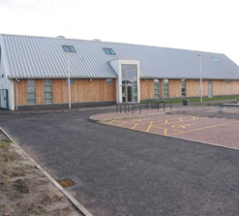

Woodmuir Primary School

Woodmuir Place

Breich

West Lothian,

EH55 8JP.

Phone: 01506 283337

Email: wlwoodmuir-ps@westlothian.org.uk

**Woodmuir Primary School**

**Policy for a Positive Learning Climate.**

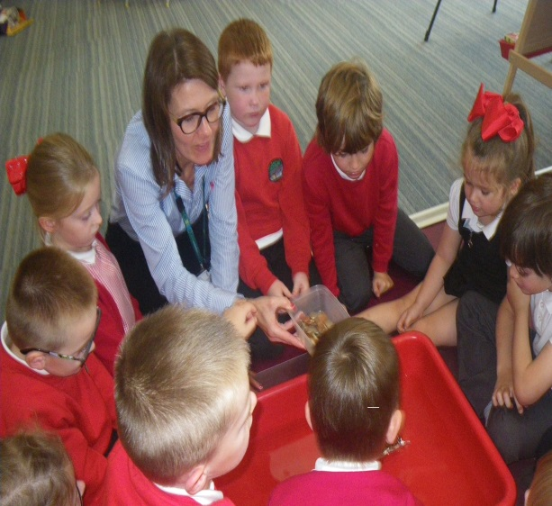

## Policy for a Positive Learning Climate

At Woodmuir Primary School we are committed to providing a positive learning climate where all pupils feel happy, safe, respected and valued as individuals.

This policy is underpinned by our shared values—***respect, responsible, collaboration, care and perseverance***.

**Rights and Responsibilities**

Everyone has a responsibility for their own behaviour, to safeguard the rights of other people and to treat others with respect, dignity and consideration. Our Climate for Learning Policy underpins the rights and responsibilities which are at the core of our beliefs of a Rights Respecting School.

**At Woodmuir Primary School we aim to:**

• Be **READY** to Learn

• Be **RESPECFUL** to all

• Keep Everyone **SAFE**

Staff have an important responsibility to model high standards of behaviour when dealing with pupils, parents/carers and each other. **Consistency in practice is essential**.

The emphasis is always on **positive action (recognition)** rather than negative action (punishment).  Problems which occur should be dealt with constructively.

**Staff Members Will….**

• Meet and greet the children at the door.

• Emphasis the importance of being valued as an individual, make everyone feel valued and like they belong.

• Promote **Ready** to learn, **Respectful** to all and keeping everyone **Safe.**

• Provide a caring and effective learning environment.

• Encourage and model relationships based on respect and understanding the needs of others.

• Make a point of recognising and praising behavior that is above and beyond.

• Repair and rebuild relationships that have temporarily broken down.

• Use a visible recognition mechanism throughout every lesson e.g. recognition board.

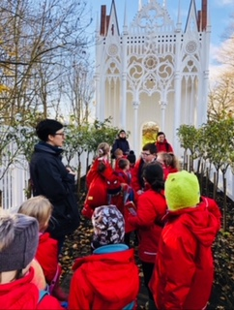

**What Parents/Carers can do to support school staff:**

• Demonstrate and promote **Ready** to learn, **Respectful** to all and keeping everyone **Safe**.

• Support School Policy for a Positive Learning Climate.

• Liaise and work with staff to support children’s behaviour.

• Take time to react to positive notes sent home, brag bands, certificates given out to children for behaviour that is over & above.

**Children will be expected to demonstrate Self-Discipline:**

• Taking responsibility for their own actions.

• Managing peer behavior by taking on responsible roles e.g. Mediators, playtime helpers, librarian helpers, dining area duties.

• Through 1:1 and individualized learning Plan (ILP) setting own targets for improved behavior.

### 

.