**Woodmuir Literacy** 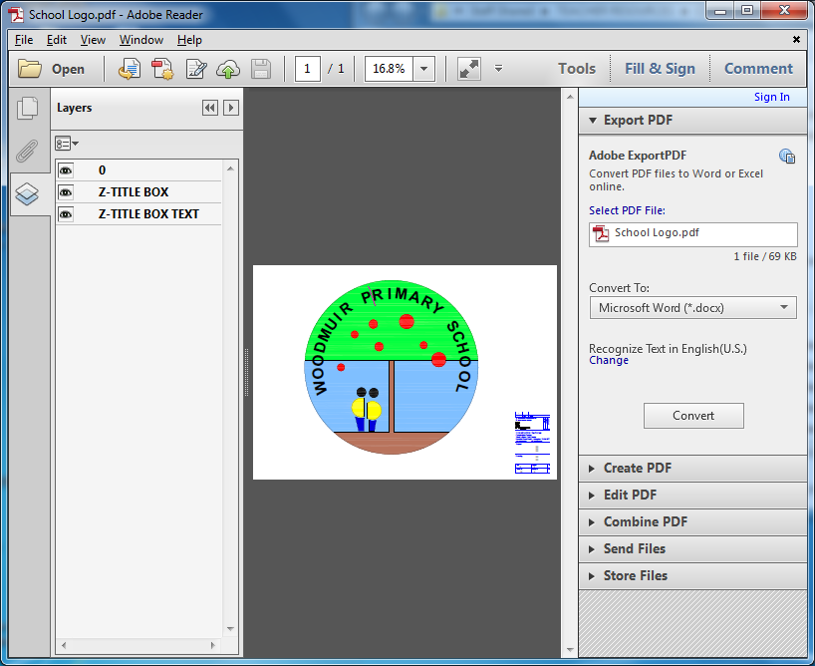

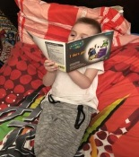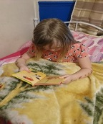 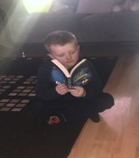

**Literacy Begins at Home**

**Research tells us that the single most important activity for enabling eventual success in reading and future learning is a child who is read to regularly from a very young age!**

**Literacy in School Early Level**

Our Primary one setting provides many opportunities for children to develop their understanding of literacy. Writing materials are incorporated into all play areas.

Rhymes, songs, syllable work, oral story-telling, exploring environmental print, sharing a love of books, mark making and building vocabulary are all key features. Big Bedtime Read encourages reading at home.

We teach Phonics in Primary One using the **Vowel House and Colourful Consonants** programme. The learning is active and fun. The children are encouraged to build and blend words in the early stages of this programme which builds the foundations for early spelling and reading.

Reading skills are also developed using the **Reflective Reading Approach** which helps develop comprehension skills. Weekly “Short Read” tasks are set using a picture book as a stimulus. Discussion skills are also developed through these activities.

Writing begins with **line drawings** in Primary One, using our “special pens”. These pens make mark making easier as the ink flows. The children are encouraged to add lots of details into their drawings. This mark making builds the foundations for forming letters and story sequencing. The children then orally tell their story which is written for them. Some children experiment with writing themselves too.

**Oral story telling** teaches children to be imaginative and creative. It also reinforces sequencing and encourages an enjoyment of sharing ideas and stories, as does the retelling of familiar stories and fairy tales.

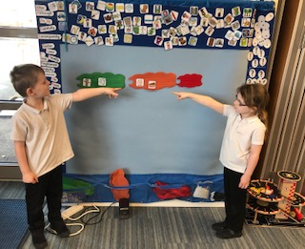.

The **Mighty Writer mat** is a resource used to teach sentence structure in Primary One. It encourages children to use a sentence opener and full stop. This visual resource allows all children to create sentence and orally share it will their peers. Children can use their images as a writing frame to help them write a sentence.

Personal writing and imaginative writing are popular with young children but alternative genres are introduced from Primary One.

**Literacy in School First Level**

Building on the work done at Early Level, children continue to learn to read in First Level through a variety of approaches and make use of a broad range of resources to suit the needs of individual learners’ needs, interests and preferences.

Children are taught and encouraged to use a range of different strategies. Children are taught

* That words are made of different sounds.
* To decode words (apply knowledge of letter- sound relationships to correctly pronounce written words)
* To understand picture books, short chapter books, information materials
* To develop sight vocabulary of tricky (irregular) words and those the child can already decode.

Children are supported to develop these as they engage with a variety of classroom library books, Big Bedtime Read loan books and local library books

In order to teach the skills involved in reading comprehension, children participate in short and long read activities on a weekly basis. These encourage the children to engage with a wide range of texts and identify genre, key information, develop prediction and inferencing skills as well as facilitating their ability through talking and listening to explain their reading references and choices.

**Writing at First Level**

The teaching of writing at First Level extends the approaches developed at Early Level and encourages learners to progress through

* putting words together to form simple sentences
* learning to develop ideas in a logical progression
* write in simple paragraphs

Each week consists of a 4 stage process

* + **Stage 1 – Preparing to write/Developing a context/Oral Planning**
  + **Stage 2 – The Writing Process**
  + **Stage 3 – Conferencing, Reading, Checking, Improving**
  + **Stage 4 – Evaluating, Next Steps, Publishing, Celebrating Success**

Children are encouraged to up-level key parts of their writing through self-, peer- and teacher assessment. Children are encouraged to write across a variety of genres such as imaginative, instructional and informational. By using a variety of resources such as our Mighty Writer mats, Clicker software and iPad apps, our children are supported to develop their writing style, skills and confidence.

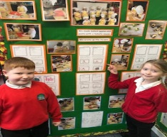

**Literacy at Second Level**

Building on the work at First Level, Second level Reflective Reading takes the form of both short and long read sessions over the course of the week, involving the children actively participating in comprehension lessons.

During the lessons children work in mixed ability trios to read and answer questions on a short text or an extract from a longer text.

**What is a Short read?** A Short Read lesson could be based on picture books, film clips, adverts, trailers and short films, poems, short stories, fiction extracts, non- fiction articles, reports and extracts, real texts such as recipes, leaflets, flyers and packaging.

**What is a Long read?** Long Read is where we look at proper full length texts and study them from beginning to end. All text forms are used for this from a film, a play, a longer poem or short story but mostly this will be from the class novel or group reading books. Children are expected to write down their answers, in full detailed sentences, in their jotters. Everyone will be reading independently and writing independently, but will be able to rely on the support of a partner, group or the teacher as necessary.

Higher order thinking skills are especially important as children must be able to explore all aspects of a text to ensure they fully understand it.

Every week we have an extended writing session and it may be linked to the short read session at the beginning of the week. Writing at second level is done in 4 week blocks, with each block focusing on a particular genre. This ensures progression and gives time for children to practise, assess and up-level their skills during a block.

Each week consists of a 4 stage process

* + **Stage 1 – Preparing to write/Developing a context/Oral Planning**
  + **Stage 2 – The Writing Process**
  + **Stage 3 – Conferencing, Reading, Checking, Improving**
  + **Stage 4 – Evaluating, Next Steps, Publishing, Celebrating Success**

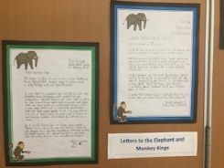

**Across the school**

Within our writing sequences we will also be teaching the spelling and grammar rules which form the core targets of writing through all levels. All stages are developing vocabulary acquisition.

Early Intervention can involve referral to speech therapy, one to one phonic interventions, online literacy diagnostics and support activities, visits from language base outreach support.

Developing our literacy Culture has included ensuring quality reading materials for all classes, big bedtime read at all stages, library time in and out of school, focussed fun whole school activities. All stages have introduced a free writing time to encourage a love of writing, pupil literacy Leaders and Librarians...