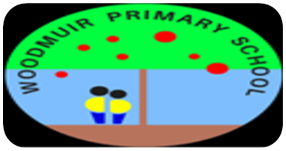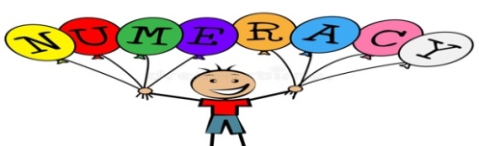

**French**

This term we will be working on our French number and food. We are also very lucky to continue to work alongside a pupil from Whitburn Academy as they complete an exchange trip to live in France for 6 months. The children are very enthusiastic learners who have impressed me with their ability to speak French, Spanish and sign language.

P2-4

This term we will be working on multiplication and division. We will use our prior knowledge on place value to help us with this and will have access to concrete, pictorial and abstract materials to aid our understanding of complex ideas. Additionally, we will be extending our knowledge of money this term. We will identify all coins and notes to £20 and will explore different ways to make the same total. We will investigate the use of technology using cards to pay for goods. Play based opportunities will be offered to deepen our understanding.

P5-7

During this term, we will be developing our knowledge of fractions and decimals. Fractions and decimals will be covered in our maths lessons on a Monday and Wednesday. We will focus on simple and equivalent fractions, decimal fractions and percentages. The importance of percentages in a real life context will also be examined. On a Thursday, our lessons will be focussed on measurement.

On a Tuesday, the whole school will be developing their knowledge and understanding within the topic of symmetry with Mrs Logan.

P2-4

During writing this term, we will be developing our creative writing skills. Learners will be working on various creative writing elements during these lessons such as setting, characters, conflict and resolution. There will continue to be opportunities to explore our learning through play across the curriculum. Reading books are still going home weekly and children are encouraged to read daily at home.

We will begin to use a new reading programme throughout the school to develop our knowledge in comprehension strategies. We will also continue to work on our reciprocal reading strategies to decode the meaning from various texts.

P5-7

In the upcoming term, we will be working on developing our creative writing. In our writing lessons we will be investigating the various elements required for creative writing and looking at the structure of these texts. In January, we will be reflecting on our targets and creating New Year’s Resolutions.

In reading we will be following the new reading programme to develop our comprehension skills. We will also be building our reciprocal reading skills through lessons on the four main strategies of prediction, questioning, clarifying and summarising each week.

The whole school will be working on Burns poetry with Mrs Logan and we have a special visit from Victoria Williamson, the author of ‘Hag Storm’ on the 24th of January 2022.

Term 3 Term Descriptor – P2-7. Miss Hurry and Miss Dunsmore

**Music**

The children continue to work really hard with Mrs Keenan on a Wednesday to work on their music skills. Learners will continue to perform singing songs beautifully, working on pace and rhythm and working on playing musical notes on the Boom whackers.



**Health and Wellbeing**

During HWB this term, the children will be focussing on different ways we can keep ourselves healthy. We will be exploring different food groups and the impact they have on our health. The children will continue to use the eight wellbeing indicators to help us think about our rights and assess our own wellbeing.

**P.E.**

This term we will be focussing on gymnastics within our P.E. slots. We will be learning skills such as cooperation and team work, balance, moving safely, learning rules, and increasing our agility and fitness.

Tuesday 1st February – Parent Council Meeting 3-4pm

Monday 14th and Tuesday 15th February – February holiday.

Wednesday 16th February – Return to school

Friday 1st April – Last day of term

Tuesday 19th April – Return to school

**Happy New Year and all our best wishes for 2022. We hope you have had an enjoyable Christmas break!**

We would like to warmly welcome Chloe Muir who will be in P5-P7 and P2-P4 this term completing her 3rd Year School Experience placement from the University of Stirling.

Mrs Logan is also delighted to be back this term working with us every Tuesday. Mrs Logan will continue teaching Food Technology on Tuesday afternoons with P2-4.

**Homework**

Children will bring a reading book home every Monday. This should be kept home until Thursday, and read with your child 2-3 times over the week. It will then be quarantined in school before any other child has access to it. Reading books and personal home readers will be given out on Monday 17th January

Please also enjoy other books with your child, encouraging them to read every evening for 10-15 minutes.

**IDL – Our Term Topic**



This term we will be focussing on the Vikings for our IDL topic. As a class, the children chose this topic and are displaying great enthusiasm to extend their learning. During our topic, we will be investigating who the Vikings were through various learning activities such as researching Viking traditions and creating our own model of Viking shields.

**Forest Schools**

This term, P5-7 will be taking part in a block of Forest Schools, where they will have the opportunity to explore and learn in the local woodlands, promoting confidence, resilience and positive Health and Wellbeing.

**Dates for your diary**

Monday and Thursday afternoon – P.E. A reminder to wear indoor shoes in class and P.E.

Tuesday afternoon – P2-4: Food Technology P5-7: Forest Schools

Monday 17th January – Sustrans Silent Disco.

Monday 24th January – Author visit, Victoria Williamson

Monday 31st January – West Lothian College trip