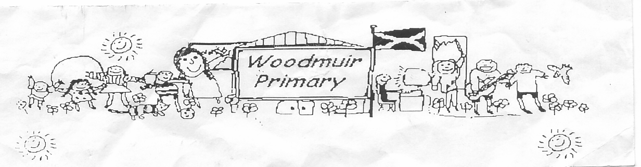**WOODMUIR PRIMARY SCHOOL PARENT COUNCIL MEETING**

**HELD ON TUESDAY 1st FEBRUARY 2022**

Present: - Mrs McNeil, Mrs McLaren, Miss Hurry, Miss Dunsmore & Mrs Henretty

Apologies: - See sheet

Proposed: Mrs McNeil

Seconded: Mrs Henretty

Welcome: Mrs McNeil welcomed everyone to the meeting.

**Matters arising from previous minutes**

Promethean Boards: Mrs McLaren shared that these are being installed on Monday 7th March.

Playground Markings: Mrs McLaren advised that she had managed to get the order done and they will be looking for access to have the markings done either Feb or Easter break.

Parkland: Mrs McNeil has still had no reply from Cathy Muldoon.

**A.O.C.B.**

Mrs McNeil asked if anyone had any AOCB to discuss at the end of the meeting.

**Head Teachers Update:**

Sustrans – Sustrans applied for funding and we have been granted an allocation of 8 bikes and 8 helmets. Discussion was had about where they would be stored. Mrs Fordyce was asked to contact our Maintenance Inspector to have this checked.

Promethean Boards & playground marking were part of the HT update but have already been discussed.

New resources - Mrs McLaren shared that they had purchased new resources for the pupils, PM Benchmark reading program, Nelson Handwriting & Spelling scheme and Heinemann Maths resources.

Digital Learning Award – Miss Dunsmore & Mrs McLaren discussed further that we are working towards our Core Digital Learning Award and are also complete.

Reading Accreditation – There are a few more details required to gain this award.

LGBT Curriculum – Mrs McLaren explained that the Scottish Government have introduced LGBT curriculum in all schools. All staff will complete the training over the next few weeks.

Mrs McLaren shared that she was unsure of our staffing situation for next year. Further discussion was had around pupil numbers.

**Date for next meeting**: Tuesday 3rd May 2022 3.05pm

Mrs Henretty asked if the school were still interested in visiting the Royal Highland Show as their end of term outing? Mrs Henretty was going to email someone involved to see if we could have set booking for different areas.