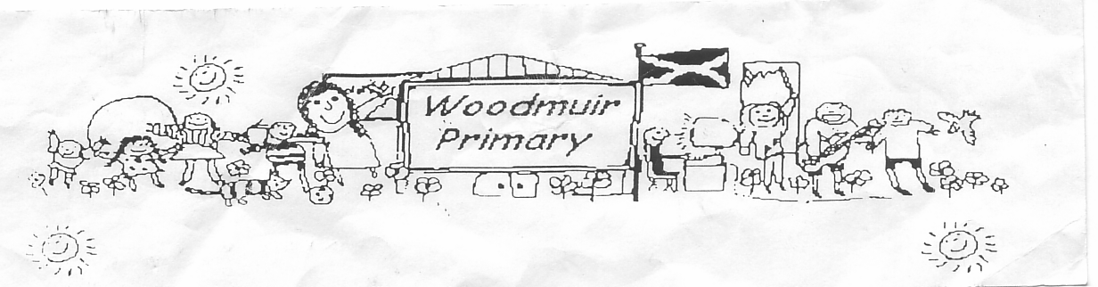**WOODMUIR PRIMARY SCHOOL PARENT COUNCIL MEETING**

**HELD ON WEDNESDAY 8TH JUNE 2022**

Present: - Mrs McNeil, Mrs McLaren, Miss Hurry, Miss Dunsmore, Mrs Henretty and Mrs Hider

Apologies: - N/A

Proposed: Mrs McNeil

Seconded: Mrs Henretty

Welcome: Mrs McNeil welcomed everyone to the meeting.

**Matters arising from previous minutes**

Promethean Boards: Mrs McLaren shared that these have been installed and are super boards for the pupils.

Playground Markings: These are all in and the children are enjoying using these at break/lunch time.

**A.O.C.B.**

Mrs McNeil asked if anyone had any AOCB to discuss at the end of the meeting.

**Head Teachers Update:**

Mrs McLaren explained that we are losing Miss Hurry and we have four new Primary 1’s this year. We have Miss Dunsmore, Mrs Hider on Monday, Tuesday and Wednesday and Mrs Blair Thursday and Friday. In the morning, the core subjects will be split between two teachers and the class will work together afternoons.

There will be PE/IDL on Monday and Thursday, Forest schools on a Tuesday and Music on a Wednesday.

A new pupil has joined from St Mary’s in Polbeth.

Mrs McLaren explained there was very little budget for Woodmuir Primary this year.

Mrs McLaren explained that the PEF money for Woodmuir is used to pay Mrs Haston. Mrs Haston has additional hours for all of these children.

Mrs McLaren explained that Reading and Numeracy will be our School Improvement plan focus this year. There is lots of staff training in these areas and we will be working alongside Peter Valentine.

In HWB, the focus will be on Pivotal behaviour management programme.

World of work plans will be implemented this year and Mrs McLaren talked about different ways of involving the parents in skills for learning, life and work.

**AOCB**

-Mrs Henretty suggested holding a village fun day as we don’t have a gala day in Breich. She then suggested that Angie would probably be keen to get involved.

-Mrs Henretty asked about more after school clubs next term and Miss Dunsmore explained we are in the process of arranging more clubs for the new session.

**Date for next meeting**: To be arranged