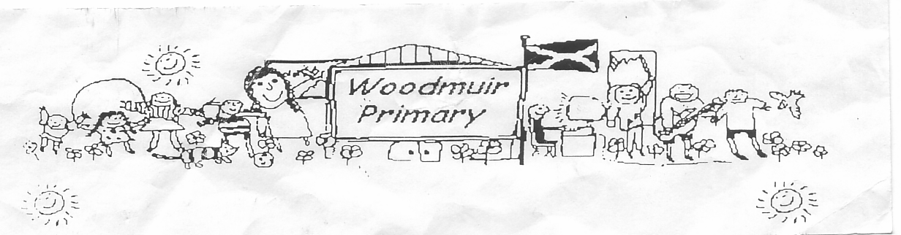**WOODMUIR PRIMARY SCHOOL PARENT COUNCIL AGM MEETING**

**HELD ON TUESDAY 13th SEPTEMBER 2022**

Present: - Mrs McNeil, Mrs McLaren, Miss Dunsmore, Mrs Henretty, Mrs Scott, Mrs Johnson & Mrs Braid

Apologies: -

Proposed: Mrs Henretty

Seconded: Mrs McNeil

Welcome: Mrs McNeil welcomed everyone to the meeting.

**Matters arising from previous minutes**

**Fun day:**

Mrs McLaren asked if someone contacted Angie about the community fun day? Mrs Henretty said she had

Contacted but had had no reply, she would send another message. Further discussion was had about

where the funding came from and the type of activities they could have. A Halloween party was also

discussed.

**Head Teacher Update**

**School Camp:**

We have 7 confirmed numbers so far for school camp in February. Pupils will be attending Lockerbie Camp

in Lockerbie.

**School Production:**

Mrs McLaren shared that all pupils will be involved in a production of ‘Grease’ with Longridge pupils next

June. Mrs McLaren discussed in more detail regarding this. Contact would be made with both cluster high

schools to check if S5/S6 Dram students could help and if we could use stage area at West Calder High

School. Discussion between parents present went onto the Nativity at Christmas.

**Curriculum Café:**

Mrs McLaren advised that we are holding a Curriculum Café on Friday 30th September at 11.30am to allow parents to come and see what their child is learning in school.

**Transition:**

Mrs McLaren advised parents that we are starting to return to normal after the COVID outbreak and pupils will start to get involved in cluster sports activities with other pupils from schools within the cluster again. Mrs McNeil asked if there could be other transition visits to WCHS? Mrs McLaren advised she would speak with Mr McDowall or Addiewell HT to see if anything extra can be arranged.

**Hoodies:**

Mrs McNeil asked if there had been any further discussion on having hoodies for the pupils instead of jackets? Some pupils don’t like the jackets as they are too bulky. Mrs McLaren asked Mrs Fordyce to contact the uniform supplier to add these onto the online shop.

**Afterschool Club:**

This afterschool club has been very successful, Miss Dunsmore spoke about contacting James to see if he can run a Multisports afterschool again, parents suggested different types of activities instead of sports.

**SEESAW:**

Mrs McNeil was asking about the SEESAW app as it doesn’t seem to allow parents to combine families together. Discussion went onto the other apps we are currently using to share our school information.

**Date for next meeting: Tuesday 1st November 2022 @ 3pm.**