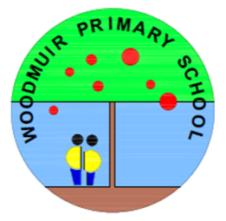

Thank you for your support in helping your child at home with their common word work and reading books.

Common word work will be sent home every week and your child will soon bring home a reading book each week.

One of the most important things you can do is read with your child regularly. This can include looking at comics, listening to audio books or sharing a novel or story book together.

Please let us know if you are having any trouble accessing Seesaw. We will soon begin using Seesaw to share learning between home and school

**Woodmuir Primary School**

**Term Descriptor – P1-4 August 2022**

**Mrs Hider and Mrs Blair**

**Class Teacher – Miss Dunsmore**

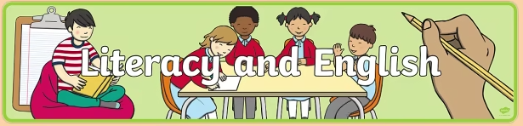

We are working on learning our sounds using Letterland. So far we have introduced s, a, t, p and i. When introducing the sounds, we look at both the lower and uppercase letters, and have practised writing the lowercase letter in handwriting. Now that we have learned a few sounds we are also beginning to blend the sounds together to read words, as well as segmenting sounds to try to spell words. We will also begin to introduce ‘tricky words’ in class, and it is great to see that pupils have been practising these at home already. Pupils who already learned sounds and tricky words will have further challenge, working on reading and writing short sentences.

In class we read books together every day and promote reading for enjoyment, as well as talking about the story, predicting and asking questions. We will also begin to work in reading groups in class and over the coming weeks and the pupils will begin to bring a reading book home each week.

In Writing this term our context will be the curriculum and wider achievement. We will be writing Recounts to retell and evaluate events and experiences. We will think about **Who? Where? When? What** happened in order? and **How** we felt? Our Reading will support our writing showing examples of Recounts, diaries and summarising stories. In Listening and Talking P1-4 will be encouraged to share events from their daily lives and weekend adventures of, for example, going to the park.

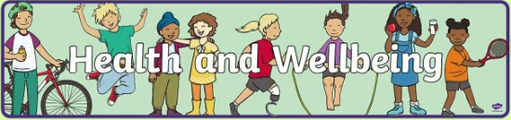

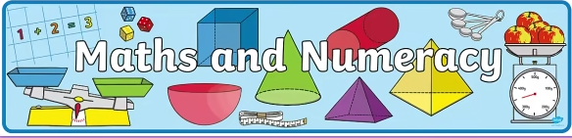

In numeracy we will be focusing on number sequences, counting forwards and backwards, estimating and counting quantities of objects. We will then move on to addition and subtraction. We will do this through a range of play and focused activities, including use of lots of concrete materials, games, songs and hands-on learning. We will also work on writing the numerals 0-10 correctly. Please encourage your child to practise counting and noticing numbers at home whenever you can!

Beyond Number we will be working on Time: Days, Weeks, Months, Clocks and O’clock times with smaller interval times for P3 and P4.

We will also work on Shape: Naming 2D and 3D shapes and their properties.



*In PE this term, with Mrs Hider we will be working on multisport skills. With Mrs Blair we will be working on football skills in preparation for the World Cup in December.

In class, we will be focussing on the wellbeing indicators of Achieving, Nurtured and Respected. More information about this can be found over the page.

https://rshp.scot/first-level/

**HWB**

This term as part of our health and wellbeing learning, we will be focussing on relationships. We will look at relationships and what makes your child unique, families, and how all our families are different, different adults who might care for children, making and having friends, what makes people alike and what makes us different and respect for others and the importance of being kind.

We also learn about making choices and decisions about our interests and the wider world of work. If you would like to share a short video describing a job, interest or hobby you have with the class we will be setting this up so that you can share it on Seesaw to share with the children.

**Interdisciplinary Learning (IDL)**

So far we have been enjoying lots of child-led learning through play. The class have shown lots of interest in construction, sand and water play. It has been great to see them develop their friendships, follow their interests and extend their learning through play.

We will soon be starting our topic about ‘Climate Change and the effect on our Community’, as part of the Levenseat Trust Acorn Award. Later in the year, our topic will be all about Scotland, leading up to a celebration for St. Andrews Day.

**Forest Schools**

We will continue to have Forest School sessions on a Monday afternoon. This term we will use the parkland immediately behind the school. We have already been exploring what bugs we can find there. We will continue to explore the area in a child-led way, and enjoy lot of games and crafts together, as well as learning how to use some tools safely. Please ensure that your child has suitable clothes for the weather on Forest School days i.e. sunhat or warm layers. We provide waterproofs for all the children, and have some spare wellies in school, although it is useful if they bring their own wellies. Please also send a spare change of clothes in your child’s bag on Mondays (especially socks!) in case they get wet or muddy. We go out in all weathers where possible.



**Dates for your Diary:**

* Friday 16th/Monday 19th September – Holiday for all
* Tuesday 20th September – Holiday for children (inservice day for staff)
* Monday 10th – Monday 17th October – Holiday for all
* Tuesday 18th October – Holiday for children (inservice day for staff)

This term we have our specialist Music teacher Mrs Keenan and the National Youth Choir of Scotland will also be working with us for a ten week block.

Thank you for your support,

Mrs Hider and Mrs Blair

**Some things to remember:**

* PE Days – Tuesday and Thursday
* Please remember to bring a water bottle into school every day.
* A pair of indoor shoes should be worn when in the classroom.
* Please remember to label all clothing and items brought to school. Thanks!