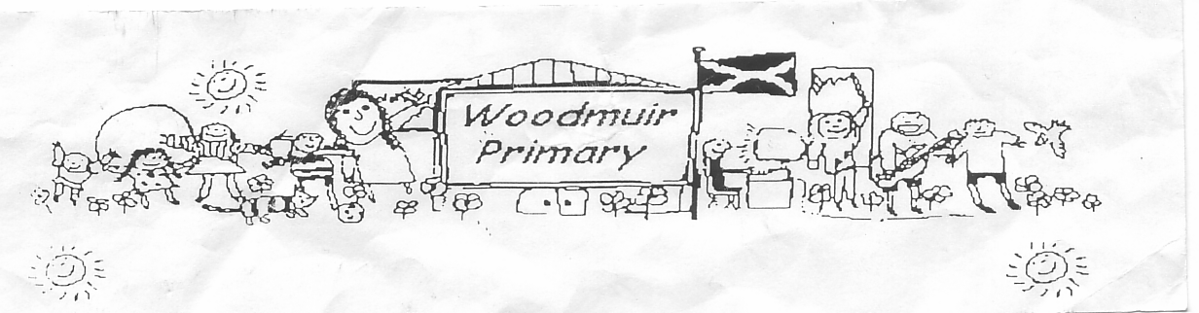**WOODMUIR PRIMARY SCHOOL PARENT COUNCIL MEETING**

**HELD ON TUESDAY 1st NOVEMBER 2022**

Present: - Mrs McNeil, Mr Johnson, Miss Dunsmore, Mrs Henretty, Mrs Johnson, Mrs Buchan, Mrs Hider, Mrs Kerr, Mrs Coulter & Mrs Braid

Apologies: -

Proposed: Mrs McNeil

Seconded: Mrs Henretty

Welcome: Mrs McNeil welcomed everyone to the meeting.

**Head Teacher Update**

**Dates for Diary:**

School Nativity Friday 16th December

Santa Fun Run/Christmas Jumper Day/Carol singing around the Christmas tree Thursday 8th December? £2

per pupil.

Party Date & Location Woodmuir PS Monday 19th December

Christmas Fayre Friday 9th December 11-12.30pm discussion was had of what was needed to be done for

this. Raffle ticket sales, donations, advertise for tables etc.

Items discussed were:

2nd hand toys, decorate a biscuit/cake, tombola, chocolate tombola, Rudolph’s carrot, pupil craft table,

wreaths, tea/coffee/mince pies, volunteers needed, boy/girl hamper.

Pupils could send invites out to the community to invite them to Carol singing.

Discussion was had about changing date for the Christmas Fayre to try and encourage more people to

attend. Miss Dunsmore said she would check with Mrs McLaren regarding this.

Discussion was also had about Home Baking policy, Mrs Fordyce explained there is a policy and she would

share it with staff and chairperson.

**Homework Questionnaire**

Miss Dunsmore explained that they had a homework questionnaire to send to parents, Miss Dunsmore

asked if had been sent out yet, Mrs Fordyce advised that it had not been sent. Miss Dunsmore asked if this

could be sent out immediately.

Mrs Henretty shared that she is having problems trying to open any links we are sending on her phone.

**Launch of AAL**

Miss Dunsmore explained that AAL is Anytime, Anywhere, Learning this will allow pupils to use their own

devices within the school to access the internet for learning purposes.

**Expressions**

Mrs Johnson explained that she is unable to access Expressions only her husband gets messages through

this channel.

Mrs Henretty explained that she get any messages/emails twice from Expressions. Mrs Fordyce advised she

will check this.

Conversation was had by all present regarding the variety of medias used to contact parents.

**Incident Reporting**

Mrs Johnson asked what the procedure was for informing parents when there has been an incident within

school. Her son had reported to her about an incident but she had not been told by the teacher. Mrs Hider

and Miss Dunsmore explained the procedures taken and Mrs Hider offered to sent home a note when there

is any incidents.

**Car Park**

Miss Dunsmore explained that another Groupcall message had been sent out regarding the car park as it is a staff car park only and parents should not be parking to collect their children.

**Date for next meeting: Tuesday 21st February 2023 @ 3pm.**