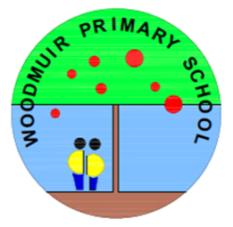

Thank you for your support in helping your child at home with their common word work and reading books.

One of the most important things you can do is read with your child regularly. This can include looking at comics, listening to audio books or sharing a novel or story book together.

We hope that you have been able to access Seesaw to view your child’s learning and achievements. We continue to encourage pupils to upload their work to Seesaw independently, whenever they feel particularly proud of their work or have something they wish to share with their family. This term we will also begin to use Seesaw for Profiling which means that each term the children will choose one or more pieces of work in Literacy, Numeracy and Maths and Health and Wellbeing. They will share it with you and say/write what skills they have been developing.

**Woodmuir Primary School**

**Term Descriptor – P1-4 January**

**Mrs Hider and Mrs Blair**

**Class Teacher – Miss Dunsmore**

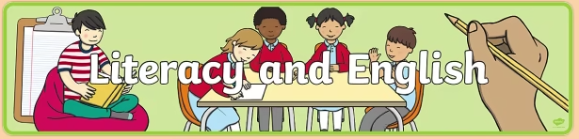

We are continuing to use Letterland to learn sounds. The pupils are engaging really well with this and love all the characters! We have now introduced all the sounds of the alphabet and will continue to consolidate this learning, encouraging pupils to blend the sounds to read words and segment sounds to spell words. They may have told you about the ‘rollercoaster trick’ for blending and the ‘elastic band trick’ to stretch words out for spelling. This term we will also be focussing on consonant blends (eg. bl, pl, gr, tr, sm, sw, nd, nt, nk), encouraging pupils to notice and use these in their reading and writing. In class, we will use of variety of play, games and activities, as well as regular spelling, handwriting, dictation and reading practise to continue to develop literacy skills.

We continue to enjoy reading and discussing stories everyday in class, and promoting reading for pleasure. Children also work in their reading groups in class throughout the week. We have begun using ‘PM Reading’ in class, which focusses on reading targets at the correct level for each child. We will continue to send home books which your child should be able to ‘sound out’. Please support them to read each evening at home, working on their decoding skills and reading fluency.

In Writing this term our context will be the curriculum and inter disciplinary learning (topic). We will be writing Descriptions and Narratives to describe characters and settings and entertain/instruct using problems and solutions. We will think about **Who? When? Where? What** was the problem? and **How** was it solved? Our Reading will support our writing using traditional tales and we will develop our prediction and clarifying skills. In Listening and Talking P1-4 will practise retelling the traditional tales and changing characters, settings and endings which will provide opportunities for role play and drama.

RME

This term we will have an RME focus all about Caring. We will be exploring who cares for us and how we can care for others. We will look at Christian stories about caring for others, as well as finding out about other world religions and their values and practices relating to caring for others.

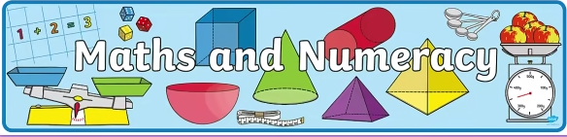

In Numeracy we will continue to build on our knowledge of number sequences, working with numbers to 30 for some, and up to100 for others. We will focus on counting backwards as well as forwards and will be learning about doubles. We will also continue to work on our subitizing skills (being able to say how many without counting). As well as this, we will begin to look at sharing quantities equally and exploring simple fractions. Some pupils will also work on counting in 2s, 5s and 10s.

Beyond Number we will be working on Data Analysis: Tally Marks, Block Graphs, Carroll Diagrams and Venn Diagrams.

We will also work on Money: Recognising coins and notes and using money in role play.



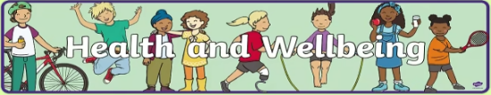

In PE this term, we will be working on tennis skills with Mrs Hider on Mondays. With Mrs Blair we will be working on Gymnastics skills linked to traditional tales on Thursdays.

In class, we will be focussing on RHSP education (Relationships, Sexual Health and Parenthood). This will be age and stage appropriate, and will include learning the names for parts of our bodies, modesty and privacy, personal space and the concept that ‘my body belongs to me’. We will also look at the concept of a lifecycle and caring for living things including plants, animals and babies (linking to our RME topic about caring).

**Interdisciplinary Learning (IDL)**

This term our topic will be led by the children. Our overview is Special Days in January and February including Chinese New Year, Burns’ Day and Valentine’s Day. After the February break our overview is to use Traditional Tales as a focus for Social Subjects, Science, Technology, Art and Drama. We aim to make tartan, cards, puppets, models, use chalk for art, make food items and plant seeds. However we will follow the children wherever they want to take their learning so this may change with their interests.

**French**

This term we will be learning about colours, number, body parts, clothing, family, food, feelings and using some of these to describe ourselves. We will also listen to some traditional tales in French.

**Forest Schools**

We will be taking a short break from Forest Schools to allow more time in the week to cover a breadth of learning across the curriculum. We plan to resume Forest Schools in the Spring and will keep you updated on this.

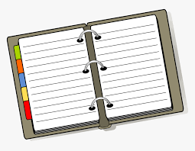

This term we will continue to work with our specialist Music teacher Mrs Keenan every Wednesday.

Thank you for your support, and as ever, feel free to ask if you have any questions.

Mrs Hider and Mrs Blair

**Some things to remember:**

* PE Days – Monday and Thursday
* Please remember to bring a water bottle into school every day.
* A pair of indoor shoes should be worn when in the classroom.
* It is useful for all pupils to bring a spare change of clothes to school every day in case of any accidents or getting wet in the playground/during play. We have very limited spare clothes at school to lend out.
* Please remember to label all clothing and items brought to school. Thanks!

**Dates for your Diary:**

* Tuesday 31st January – planned strike action, school expected to closed
* Monday 13th February – Friday 17th February – holiday for all
* Monday 20th February – Holiday for pupils, in-service day for staff
* Tuesday 28th March – P3 – P7 trip to Riverside Museum, Glasgow
* Monday 3rd April – Friday 14th April – Holiday for all