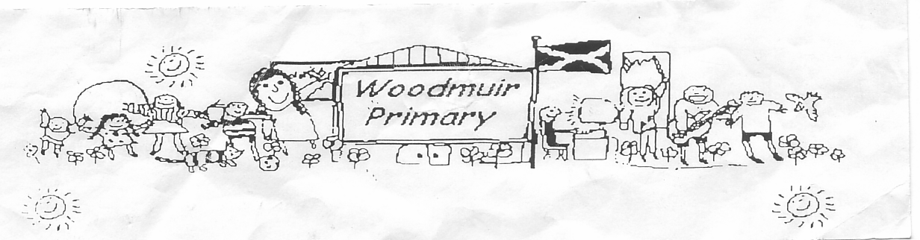**WOODMUIR PRIMARY SCHOOL PARENT COUNCIL MEETING**

**HELD ON TUESDAY 21st FEBRUARY 2023**

Present: - Miss Dunsmore, Mrs Henretty, Mrs Hider, Mrs Braid, Mrs McLaren

Apologies: - Mrs McNeil

Proposed: Mrs Henretty

Seconded: Mrs Braid

**A.O.C.B. to discuss later**

Mrs McLaren asked if any AOCB to discuss at the end of the meeting. – None was given

**Head Teacher Update**

**AAL**

Mrs McLaren explained that the pupils can now bring in their own devices from home for AAL (Anywhere,

Anytime Learning). The council and school are working towards their Digital Award. Mrs McLaren explained

that there are some rules etc. to follow and these would be discussed with the pupils before allowing them

to use their own device.

**Expressions**

Mrs McLaren asked if everyone was getting the Expressions texts/emails ok. Mrs Henretty just advised as

before that she is unable to open links sent in any messages on her phone.

**Homework Questionnaire**

Miss Dunsmore shared in detail the replies from the questionnaire sent out regarding homework. Mrs

McLaren discussed in more detail the complications of homework for some families for different reasons.

**Rookie Rockstar Workshop/Concert**

Mrs McLaren shared that Rookie Rockstar was working with the pupils today and have agreed to come in

tomorrow & Thursday. The pupils will put o a concert on Thursday 2nd March to show parents what they

have been learning.

**STEM Curriculum Cafe**

Mrs McLaren advised that we were holding a STEM Curriculum café on Friday 24th March. Parents will be

invited to attend.

**Outdoor Learning**

Mrs McLaren shared that Forest Schools had restarted and Mrs Hider discussed in more detail what they had done today. Mrs Fordyce to contact a few places to try and get new planters.

**Chairperson resignation**

Mrs McLaren advised that Mrs McNeil had resigned from the Parent Council. Mrs Henretty was appointed new Chairperson and Mrs Braid was appointed Vice Chair.

**Lockerbie Camp**

Mrs McLaren asked if parents were happy to rebook Lockerbie or if they wanted the pupils to try somewhere different? Further discussions were had comparing Lockerbie Manor to Dalguise.

**Transition P7-S1**

Parents were advised that transition for P7 pupils was starting after the Easter holidays. Nursery to P1 would also be starting that term.

**A.O.C.B.**

Mrs Henretty asked that when the pupils have outings could they be more local. i.e. Panto why have it at Stirling when we have 2 theatres on our doorstep.

Mrs Braid asked about the visits to WCHS, Miss Dunsmore explained that we have one booked.

Mrs Henretty asked if they were doing an end of term/start of term trip? Mrs McLaren said she would ask the pupils what they would prefer.

Parents discussed that they were unsure when Dress down days were sue to happen. Miss Dunsmore agreed to send out dates for future dress down days.

Mrs McLaren explained that there was a small budget from PEF Funding for a project for the pupils. Mr Finch shared the pupils ideas.

Mrs McLaren shared that P5-P7 pupils will have a day at Lowport canoeing. This is booked for April 2023.

Discussions then went onto World Book Day activities planned, Mrs Henretty suggested that the pupils decorate a white t-shirt with their favourite character. Miss Dunsmore and Mrs McLaren explained that they did not want parents being out of pocket and buying an outfit.

**Date for next meeting: Tuesday 25th April 2023 @ 3pm.**