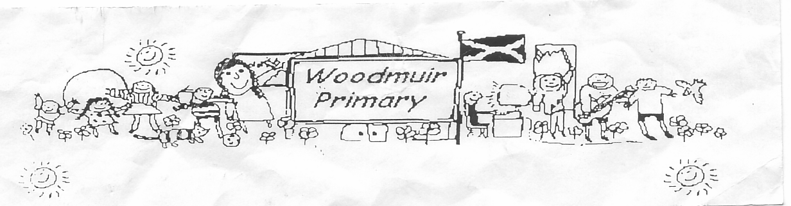**WOODMUIR PRIMARY SCHOOL PARENT COUNCIL AGM MEETING**

**HELD ON TUESDAY 3rd OCTOBER 2023**

Present: - Mrs Henretty, Mrs Rumbles, Mrs McLaren, Miss Dunsmore

Apologies: - See attached sheet

Proposed:

Seconded:

**A.G.M**

Mrs McLaren asked Mrs Henretty if she was considering staying on as Chair which Mrs Henretty agreed. No vice-chair was allocated.

**A.O.C.B.**

Mrs Henretty asked if Halloween party was being held at Woodmuir PS. Mrs McLaren replied ‘Yes’, Miss Dunsmore replied that the pupils took a vote and it was half/half so teachers decided to keep it at Woodmuir. Mrs McLaren explained that the staff have decided to ask the pupils each time there is an activity if they wish to do it with Longridge or at their own school. Mrs Henretty asked about the pupils getting treat bags and Mrs McLaren agreed. Miss Dunsmore asked Mrs Henretty if she would shop/coordinate this.

Mrs McLaren then discussed putting a letter out to parents to see if they have any unused/unneeded/out grown costume that they would be happy to donate to the school. Talk was had about having a rail in front foyer offering seasonal items, school clothing or jackets etc. This would help reduce the cost of the school day for parents.

Mrs Henretty asked if Panto was booked and where was it going to be as parents have mentioned that they would rather utilise closer to home theatres etc. Mrs McLaren explained that Panto was already booked and that the pupils would be going to see Sleeping Beauty at Howden Park Centre on Tuesday 19th December in the afternoon.

**Head Teacher Update**

**10th Birthday Coffee Morning**

Mrs McLaren shared that we were having a coffee morning to celebrate our 10th birthday on Friday 3rd

November. Mrs Henretty said she would contact the Community facebook admin to have a post put up and

open the coffee morning to the community. Mrs McLaren asked Mrs Fordyce to book Zoolab for the pupils.

**Christmas Fayre/Santa Fun Run**

Our Christmas Fayre will be on Friday 8th December. Discussion was had between present members as to

what we could have at the Fayre, stalls, tattoo’s, Mrs Fordyce to send letters for donations, Kids/Adult

tombola, raffle etc, homebaking, decorate biscuit, reindeer food, games, crafts, wreaths, 2nd hand stall,

guess the birthday, water/wine.

It was agreed at the meeting that the Santa Fun Run would be in the morning before the Christmas Fayre.

Mrs Fordyce was asked to order medals.

**Christmas Panto**

Panto has been booked for Tuesday 19th December in the afternoon at Howden Park Centre.

**Curriculum Café**

It was discussed that the Curriculum café was a success and we would arrange another before the

Christmas break. Suggested date was Friday 17th November and this time the theme would be Literacy.

**PEF Funding**

Mrs McLaren shared that we receive £4900 PEF Funding and most of this is used to employ Mrs Haston in the afternoons to help with interventions. It was also discussed that a small amount of this funding was to be spent by the pupils and some suggestions were discussed.

**Probationer Teacher**

Mrs McLaren shared that Miss Megahy our probationer teacher is doing well in class.

**Fundraising**

Mrs McLaren explained that to help reduce the cost of the school day for parents we would need to do some additional fundraising. A further discussion was had by all in the meeting about suggestions for this.

Rags2RichesforSchools – Clothing collections, Mrs McLaren asked Mrs Fordyce to arrange a collection.

Mrs Rumbles suggested filling a smarties tube with 20p. Mrs McLaren suggested giving the pupils this and to have a return date before Christmas.

Miss Dunsmore shared more diary dates – Carol singing around the Christmas tree – Wednesday 20th December PM was suggested. Pupils will make leaflets and they will leaflet drop to advertise this.

Christmas Party – Monday 18th December. Miss Dunsmore will ask Mhairi if her Dad is able to be Santa.

Nativity – Friday 15th December.

Discussion then returned to fundraising, it was suggested that the last Friday of every month the pupils would have a dress down with a theme and 50p donation. It was then suggested that on the last Friday of every month we could ask for a donation to the foodbank we have in the front foyer. It was discussed that we would combine the above and let parent know which option it is that month.

There was a discussion regarding providing free fruit for pupils. It was also discussed that we could ask parents to donate unused/outgrown Christmas jumpers for our rail. Discussion was had that we could have 1 week of Christmas jumper day, this was rejected as it would maybe cause parents to buy extra or struggle to have washed/dried each day. It was then suggested that over the month of December each Friday the pupils would have a Christmas theme dress down day and this would be shared with parents. Christmas colour, Christmas socks etc.

Mrs Rumbles asked if there could be more activities with WCHS, Miss Dunsmore & Mrs McLaren explained that they are already in discussion with WCHS regarding this.

**Date for next meeting: Tuesday 7th November 2023 @ 3pm.**