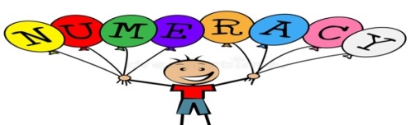

**Numeracy**

Every day we will have a 10-minute number talks lesson which is a strategy to build flexibility, accuracy and efficiency in mathematical thinking through the discussion and sharing of mental maths strategies. It is a short daily routine that allows pupils to contribute to meaningful dialogue concentrating on how to answer Numeracy problems. This term the focus will be on **multiplication and division number talks.** During this term, we will be developing our knowledge of **Decimals, Fractions and Percentages**.

**Mathematics**

In maths the focus areas will be **Data analysis, Patterns and Relationships and Simple Equations.**

We will be consolidating our knowledge of the four operations throughout this term along with aspects of measurement and shape. Within our maths lessons, we will be investigating their links to real life contexts which will help to deepen our understanding. We will use concrete, pictorial and abstract materials to aid our understanding of complex ideas as well as maths through stories.

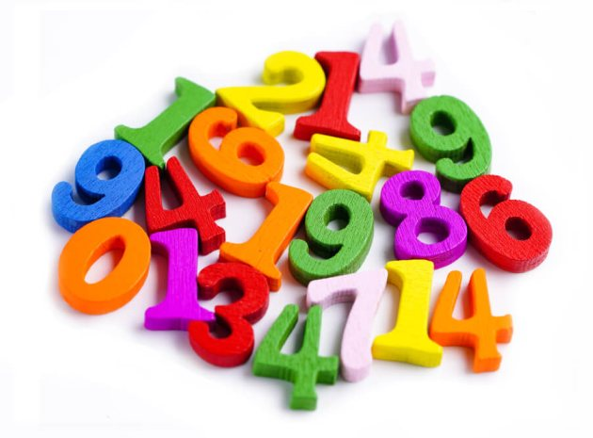

**Writing**

In the upcoming term, we will be working on developing our writing with Mrs Blair. In our writing lessons we will be working on the **Explanation** genre to explain how or why something occurs and **Recount** where we will retell and evaluate events and experiences. The context of writing lessons will be based on the curriculum/ IDL and wider achievements. We will continue to reflect on our targets throughout our literacy lessons. This term we will also be working on further self/peer assessment strategies during and after our writing lessons in order to assess our strengths and next steps.

**Reading**

In reading we continue to work with our new PM reading scheme which is building our comprehension skills. We will also be building our independent reciprocal reading skills through lessons on the four main strategies of **prediction, questioning, clarifying and summarising,** working on a short read text linked to Explanation and Recount genres. In addition to this we work on our long read texts every day, where on a Monday we will work on a think aloud task with our group, on a Wednesday we will work on applying our comprehension strategies and on a Thursday we will be more creative! One novel will continue to go home on a Monday and this should be read 2/3 times over the week, ready to complete a written task in class. A personal book of choice will also go home each week, to read for pleasure.

**Spelling and Handwriting** During our morning soft start we will continue to work on spelling rules and strategies. Handwriting skills will also be practised once a week during soft start time.

Term 3 April-June 2024 Term Descriptor P4 - P7 Miss Dunsmore and Mrs Blair

**French**

French learning this term will include vocabulary on learning numbers to 31, personal greetings and the weather. French lessons will continue to be either discrete lessons standing alone or built in to the daily classroom life and daily conversations, eg, the register, ordering lunches, general greetings and the weather.

**Music**

The children continue to work really hard with Mrs Keenan on a Wednesday afternoon. This will be whole school and will involve performing songs and performing on instruments, individually or as part of a group, to communicate the mood and character of a piece of music through, for example, the use of appropriate dynamics and expression.



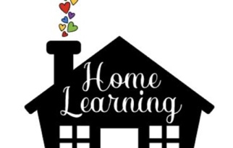

* **Our RSHP curriculum has been in place for some years, it is part of Curriculum for Excellence. All content is age and stage appropriate for learners 3-18 years.** **There is information for parents and carers, ideas about communicating between school and home, reading lists for school libraries and reading at home. The resource is accessible and open to all. everyoneeveryone;parenand carers can see what is being delivered in school.**

**Health and Wellbeing RSHP and Physical Education**

During PE lessons we will be working on Cross country running, Fitness and Sports on a **Monday and Tuesday** afternoon. Below is our RSHP content this term. Information for parents and carers about RSHP learning at Second Level at school and at home: [**https://rshp.scot/second-level/**](https://rshp.scot/second-level/)

|  |  |  |  |
| --- | --- | --- | --- |
| ***Second Level***  *When it comes to* ***relationships*** *children learn about:*   * What makes them unique and what makes people alike and what makes us different (diversity) * Making and having friends * *Being a boy and a girl, and that they can be any kind of boy or girl they want to be* * *Loving relationships and being attracted to others* * *Respect for others and the importance of being kind – in our face-to-face relationships and online.*     *When it comes to* ***being safe*** *children learn about:*   * *Social media and being safe and smart online* * *Feeling safe and unsafe* * *Different kinds of abuse and neglect that can happen to a child* * *What we mean by consent* * *Who they can go to for help and support.* | When it comes to **being safe** children learn about:   * Social media and being safe and smart online * Feeling safe and unsafe * Different kinds of abuse and neglect that can happen to a child * Consent * Who they can go to for help and support. | When it comes to **growing up and learning about their body** children learn about:   * Making choices and decisions * Looking after their body and keeping clean * Puberty and how the bodies and emotions of both girls and boys * change as they grow * What ‘having sex’ is and about contraception and condoms. * bodies and emotions of both girls and boys change as they grow * What ‘having sex’ is and about contraception and condoms.     When it comes to **conception, pregnancy, birth and being a parent/carer** children learn about:   * How a baby is made (conception) * Pregnancy and how a baby is born * Being a parent and thinking about what kind of parent they would be.   Information for parents and carers about RSHP learning at Second Level at school and at home: <https://rshp.scot/second-level/> | * Social media and being safe and smart online * Feeling safe and unsafe * Different kinds of abuse and neglect that can happen to a child * What we mean by consent * Who they can go to for help and support. |
| * Being a boy and a girl, and that they can be any kind of boy or girl they want to be * Loving relationships and being attracted to others * Respect for others and the importance of being kind – in our face-to-face relationships and online. | * Making choices and decisions * Looking after their body and keeping clean * Puberty and how the bodies and emotions of both girls and boys change as they grow * What ‘having sex’ is and about contraception/condoms. | * What ‘having sex’ is and about contraception and condoms.   When it comes to **conception, pregnancy, birth and being a parent/carer** children learn about:   * How a baby is made (conception) * Pregnancy and how a baby is born * Being a parent and thinking about what kind of parent they would be. | * Making choices and decisions * Looking after their body and keeping clean * Puberty and how the bodies and emotions of both girls and boys change as they grow * What ‘having sex’ is and about contraception and condoms. |

**P.E**

This term we will be focussing on **Cross Country and Club Golf i**n our P.E. lessons on Tuesday and Thursday afternoons with Mrs Blair.

**Homework**

Children will bring a reading book home every Monday. This should be kept in children’s school bags as we will have reading follow up tasks during the week in class. Please read with your child 2-3 times over the week and also enjoy other books with your child, encouraging them to read every evening for10-20 minutes.

**Thank you for your continued support once again. All dates/topics are subject to change and we will keep you updated regularly on the usual platforms.**

**Useful Diary Dates below for this term**

|  |  |
| --- | --- |
| Wed 23 April Lowport Canoeing (P5-P7) | Thu and Fri 23rd and 24th May P7 West Calder HS transition days |
| Wed 1st May- Fri 3rd May P5-P7 School Camp | Mon 27th May West Lothian Library visit. Whole school |
| Mon 6th May BANK HOLIDAY | **Other dates will come out separately when confirmed.** |
| Tue 7th May Inset day | **JUNE DATES** |
| Wed 8th May Cross country – (P6 event only) | Thu 20th June Royal Highland Show visit for whole school |
| Mon 13th May WCHS visit to the Science Department (P4-7) | Mon 24th June- P5-P7 Bowling leavers treat to Dear Park Livingston |
| Fri 17th May – Pajamarama day | Thu 27th June P7 Leavers Service at 2pm |
| Mon 20th May BANK HOLIDAY | Fri 28th June – Last day of term fun –Summer Holidays |

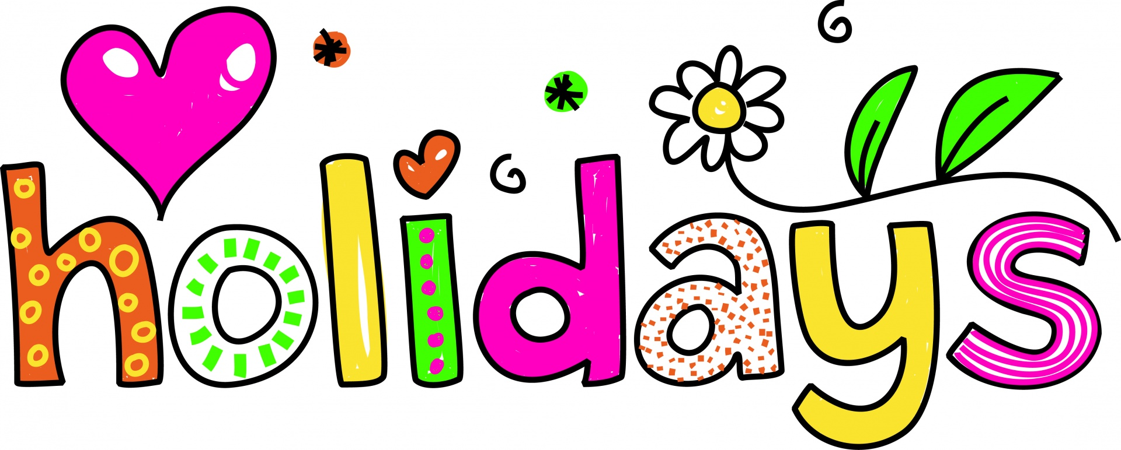

End of Term 3: Friday 30th June. Summer holidays begin: Monday 3rd July.

**IDL – Our Term Topic**

***Whole school project with Miss Megahy on Monday and Thursday afternoons***

This term the topic has been voted for by the children and it is Ancient Egypt. We will also be in our pupil voice groups once a month.

School Clubs

Thank you for your engagement with last term’s clubs. This term, we are hosting Monday lunch time fitness (free), Tuesday after school football costing £2 per session from 3.05-4PM, Tuesday lunch time craft club and Wheelie Wednesday during lunch time - both free.

