Woodmuir Primary School 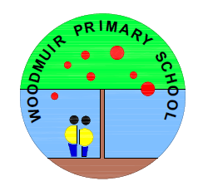

Term 1 Calendar

Date | Event
Thursday 22nd August, 2024 | Meet the Teacher 2.30pm
Friday 30th August, 2024 | Healthy Café – 11.45am – 12.15pm
Friday 13th – Tuesday 17th September, 2024 | September Weekend (School Closed)
Wednesday 18th September, 2024 | All pupils and staff return to school
Thursday 19th September, 2024 | Risk Factory – P6 and P7 children only
Friday 27th September, 2024 | Curriculum Café – Levenseat Project
Friday 27th September | Foodbank Friday (Non-perishable donations welcomed)
Tuesday 1st October, 2024 | Parent Council Meeting – 3.05pm
Monday 7th October, 2024 | Parent Consultations
Thursday 10th October, 2024 | UNICEF Day for Change Assembly 2.15pm (All classes)
Friday 11th October, 2024 | School finishes at 12.35pm for October Break
Tuesday 22nd October, 2024 | All pupils return

