

WOODMUIR PRIMARY SCHOOL
SCHOOL IMPROVEMENT PLAN

2024 / 2025

Factors Influencing the Improvement Plan

School Factors
Addressing Action Points identified in school’s Self Evaluation procedures
Cluster Improvement Priorities
Equity Priorities

Local Authority Factors
Moving Forward in Your Learning Guidance
Literacy and Numeracy West Lothian Priorities, HWB
Raising attainment, including closing the gap (West Lothian Raising Attainment Strategy)
Transforming Your Council
Corporate Plan
Education Services Management Plan
West Lothian Parental Involvement and Engagement Framework
Equity Team and additional allocations, Pedagogy Team
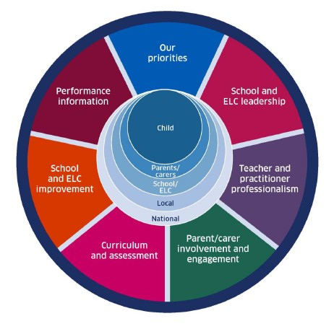
National Factors
Coronavirus (COVID-19): Guidance on reducing the risks from COVID-19 in school
Moderation Cycle and Assessment
National Improvement Framework / Scottish Attainment Challenge / National Improvement Hub / Raising Attainment for All
Pupil Equity Funding/Equity Audit
How Good is Our School? 4th Edition and How Good is Our Early Learning and Childcare?, National Standard for ELC, Quality Framework for day care of children
Getting it Right for Every child (GIRFEC)
Curriculum for Excellence Refresh
Realising the Ambition
Developing Scotland’s Young Workforce
Child Protection Procedures
GTCS professional standards and professional update 2021
Achieving Excellence and Equity 2022: National Improvement Framework and Improvement Plan
Putting Learners at the Centre: Towards a Future Vision for Scottish Education, The Ken Muir report, March 2022.
UNCRC
Presumption to provide education in a mainstream setting 2019

Woodmuir Primary School

Vision, Values and Aims

Vision

As a school community we have spent time revisiting our Values and Vision to ensure they are a true representation of who we are at Woodmuir and what we want for our learners. (Developed by pupils, staff, parents and community 2017/18)

Values

Courage, Friendship, Determination

Our AIms
- To ensure that Health and Wellbeing is at the centre of everything we do
- To celebrate diversity and ensure equality for all children
- To create a relevant and exciting curriculum to motivate and inspire children
- To provide high quality learning experiences in and out the classroom
- To form positive partnerships between pupils, teachers, parents and the local community
- To celebrate all children’s achievements both in and out of school
- To give children opportunities to develop leadership skills within school and the local community
- To have fun and have a love of Learning

Woodmuir Primary School Curriculum Rationale

Wodmuir Primary School
Values
Community
Belief
Love
Equality
Respect
Our Priorities
Health & Wellbeing
Teaching, Learning & Assessment
Literacy
Numeracy
Developing The Young Workforce
Digital Technologies

Learning, Teaching & Assessment
Digital Technologies
Play Based Learning Revising approaches to teaching literacy
Interdisciplinary Learning
Agile Learning
Assessment
Moderation
Developing the Young Workforce
Experiences which equip our learners with opportunities for their future.
Agile Learning
An agile learning culture aims to immerse young people in a learning environment in which they gain the skills, knowledge and adaptability to flourish.

Taking notice of changing needs and circumstances within our community and adapting our curriculum.

No boundaries:
Learning is indoors, outdoors, at school, at home, online, local and global
Pupils Leading Learning
Self-evaluation
Pupil as Leaders
Head Pupils
Learning Ambassadors
Staff CLPL
Self-Evaluation
Health & Wellbeing of All
Pupils self-reporting and supported by their trusted adult.
Wider Achievements
Relationships are at the heart of everything we do.
Nurturing Approach
Shared Ownership: pupils, parents and teachers.
Motivation through engagement: interests, passions and initiative.
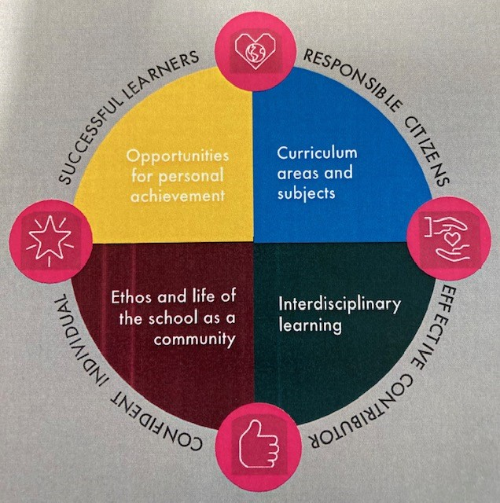

Contextual Data Analysis and Rationale for 2023/24 School Improvement Plan
Woodmuir is a small non-denominational primary school, situated in the village of Breich in West Lothian. We have 2 small multi-composite classes with a current roll of 21 pupils. Our staff include a 0.5 Head Teacher, 0.5 Principal Teacher 0.5 Class Teacher, 1 x full time class teacher and 2 x pupil support workers. Health and wellbeing is at the heart of everything we do at Woodmuir Primary School and our positive school ethos is built on our school values, positive relationships, mutual trust and respect for one another. School staff have positive relationships with all parents and carers and work closely with them to support and drive whole school improvements.
School Improvement Priorities 2023-34
Last session we developed our learning, teaching and assessment approaches in literacy and numeracy by introducing Higher Order Thinking Frameworks in both classrooms to develop children’s higher order thinking skills. Class teachers introduced literacy and maths working walls and these are being used in the classrooms to support learning and teaching. Staff were involved in cluster moderation sessions of the numeracy and maths approaches implemented across the cluster over the last two years and this evidence was then used to create a Maths Strategy.

School Improvement Priorities 2024-25
This session, class teachers will continue to embed Higher Order Thinking Skills in literacy and numeracy and will be trained in PM Oracy to support the teaching of listening and talking across the curriculum. Class teachers will undertake a ‘Practitioner Enquiry’ to develop pedagogical approaches in numeracy and maths.

Data Analysis
Our tracking data shows that our overall attainment in Reading, writing, listening and talking, numeracy and maths is good and that most children are achieving the expected CfE level in Literacy and Numeracy. We will continue to develop our pedagogical approaches in Literacy and Numeracy to ensure our learning and teaching is of the highest quality. We work closely with pupils, families and partner agencies to remove barriers to learning for our pupils.

Health and Well-being
Most children have reported positively across the health and wellbeing indicators. There are universal supports in place to support all children’s health and wellbeing and targeted action plans in place for children who required addition support.

School Improvement Priorities 2024-25

Anywhere School - School Improvement Planning for Ensuring Excellence and Equity
School priorities linked to knowledge and data as identified on previous page | NIF Driver | Proposed actions | Timescale | Measures of Success
Improvement in all children and young people’s wellbeing:  Work will all Stakeholders to create a Positive Relationships Policy and Anti-Bullying Strategy.  Work with all stakeholders to create a shared vision and aims. | ☐School and ELC Improvement.  ☒School and ELC Leadership  ☒Teacher and Practitioner Professionalism  ☒Parental Engagement  ☒Curriculum and Assessment  ☒Performance Information | - Refresh the School’s Positive Relationship Policy and Anti-Bullying Strategy.  - Whole school to work towards the Gold Right Respecting School Award.  - Refresh school vision and aims. | Sep 24  Aug 24  Jan 25 | Measures  - Learner conversations  - Pupil Ethos Survey  - Self-Reporting of Wellbeing Indicators  Measures  - Learner conversations  - Classroom observations  - Pupil Participation Groups
Raising attainment for all, particularly in literacy and numeracy(universal):  Improvement in children’s ability to assess, evaluate, apply and synthesise information.  Improvement in children’s talking and listening skills in numeracy and mathematics. | ☒School and ELC Improvement  ☒School and ELC Leadership  ☒Teacher and Practitioner Professionalism  ☒Parental Engagement  ☒Curriculum and Assessment  ☒Performance Information | - Class teachers to be trained in PM Oracy to support listening and talking.  - Embed higher order thinking skills in literacy and numeracy.  - Class teachers to undertake a ‘Practitioner Enquiry’ linking to the Building, Thinking Classrooms work. | Nov 24  Aug 24  Aug 24 | Measures  - Teacher confidence  Measures  - Learner conversations  - Teacher confidence  Measures  - Teacher confidence and beliefs  - Classroom observations  - Learner conversations
Tackling the attainment gap between the most and least advantaged children (targeted):  X state priority  (Placing the human rights and needs of every child and young person at the centre of education) | ☒School and ELC Improvement  ☒School and ELC Leadership  ☒Teacher and Practitioner Professionalism  ☒Parental Engagement  ☒Curriculum and Assessment  ☒Performance Information | ‘All West Lothian schools are committed to continuously developing their approach to ensure equity and tackle the poverty related attainment gap. Each school’s PEF Summary provides an overview of their approach and an outline of how Pupil Equity Funding is being used to provide a range of universal and targeted approaches and interventions.  Please follow this link (INSERT HYPERLINK) to view our PEF Summary and find out more about our use of Pupil Equity Funding.’ |  | Documented in PEF Plan
Improvement in employability skills and sustained, positive school leaver destinations for all young people:  To embed outdoor learning in the curriculum and ensure that all children are participating in a range of progressive and creative outdoor learning experiences.  To introduce meta-skills across the curriculum to help children recognise, understand and record their skill development.  Cluster  Learners will have an equitable experience within all areas of the Expressive Arts. | ☒School and ELC Improvement  ☒School and ELC Leadership  ☒Teacher and Practitioner Professionalism  ☒Parental Engagement  ☒Curriculum and Assessment  ☒Performance Information | School staff to provide regular, enjoyable and challenging opportunities for all children to learn outdoors.  Introduce the Woodmuir Learners’ Skills Toolkit in both classes containing the four C’s (communication, critical thinking, creativity and collaboration.  Introduce the Meta-Skills Progressions Framework across all CfE levels.  Refresh the school’s curriculum rationale and design.  Class teachers to work with Expressive Arts Specialists from WCHS to plan and deliver high quality learning and teaching experiences in Art & Design, Drama and Music. | Aug 24  Aug 24  Aug 24  Sep 24 | Measures  - Leuven Scale  - Learner conversations  Measures  - Learner conversations  - Classroom observations  - Pupil Profiles  Measures  - Learner conversations  - Classroom observations

