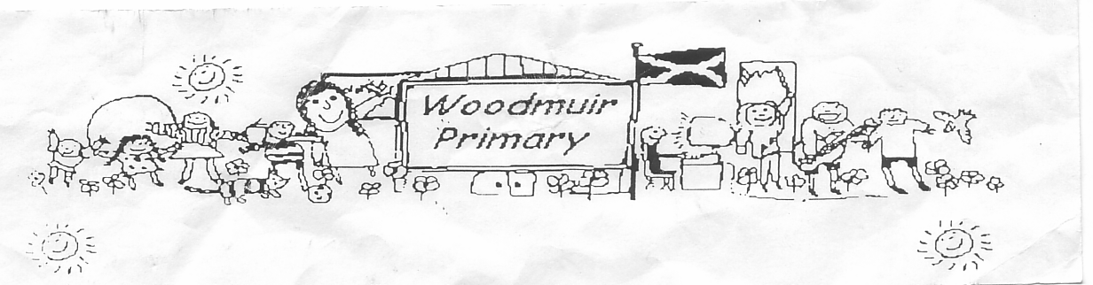**WOODMUIR PRIMARY SCHOOL PARENT COUNCIL AGM MEETING**

**HELD ON TUESDAY 1st OCTOBER 2024**

Present: - Mrs Henretty, Ms Meilke, Mrs Rumbles, Mrs Thorburn, Mr Johnson, Mrs McLaren, Miss Dunsmore

Apologies: - See attached sheet

Proposed: Mrs Henretty

Seconded: Mrs Rumbles/Mr Johnson

**Previous Minutes**

A discussion was had from the previous minutes about dress down days. It was agreed that the last Friday of the month would be foodbank Friday, dress down and donation via iPay.

**A.G.M**

Mrs McLaren asked Mrs Henretty if she was considering staying on as Chair which Mrs Henretty agreed. Mrs McLaren asked if anyone would like to become vice-chair Mrs Thorburn agreed.

**Head Teacher Update**

Mrs McLaren handed out a simplified school improvement plans and explained in more detail to parents

present .

**PEF**

Mrs McLaren explained the information on our PEF statement. How much Woodmuir PS got and where

monies were being spent.

**Bank Statement/Fund Raising**

School Funds - £2579 this is used to subsidise buses etc.

Asda Rewards - £71

Cauliflower Cards - £63

Dress downs – monthly

Red Nose Day – March 2025

Christmas Fayre/Santa Fun Run – December both being held on the same day

Halloween Party – in school Friday 1st November – Mrs Henretty asked what she had to buy again and then

there was a discussion about costume exchanges for pupils. It was agreed that this would be put on the

clothing rack at the front entrance. Further conversations were had around the party.

Panto – Oor Aladdin – Bathgate Regal Theatre

Christmas Party – last week of term

**A.O.C.B**

Assemblies – Mr Johnson asked about the minister come into school. A discussion was had regarding this.

Parents/School communication – different information is being sent to parents regarding events within

school. It has been decided that the only communication regarding events will be via the newsletter that

Mrs McLaren puts out weekly. No groupcalls will be sent. Mrs Reid asked if more information can be put on

for the events as they are new to schools and they did not know that parents were welcome to attend a

previous event.

Afterschool Clubs – Lots of miscommunication around afterschool clubs. Mrs McLaren explained that there

were too many 1 week and we have had to cap it. After the October break pupils will book into a 5 week

block so hopefully this will help. Mrs Rumbles asked about the week it was cancelled do we have a

contingency plan in place. Mrs McLaren explained that as these were afterschool clubs it would be the

parents responsibility to have a contingency plan in place.

Behaviour at Afterschool classes – Mrs Henretty explained that the Art teacher had asked her to bring up

about the pupils behaviour. Miss Dunsmore was asked to make up a code of conduct and if pupils did not

adhere to this then they would not be allowed to return to afterschool block booking.

Holiday details on School App – Parents highlighted to us that the dates were wrong on the school app for

the holidays. Mrs Fordyce said she would call and fix that in the morning.

X/Twitter – Mr Johnson asked about the photography policy. He did not want his child on X/Twitter at the

moment as the account was not private. Mrs McLaren said she would contact Digital team to ask for

advise.

**Date for next meeting:**