Woodmuir Primary School 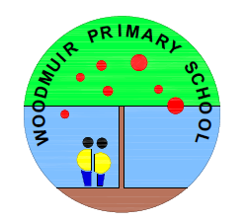

Term 2 Calendar

Date | Event
Wednesday 23rd October, 2024 | P5-P7 – Food and Farming Trip (Full Day)
Thursday 31st October, 2024 | Halloween Party (P1-P7) 1.30 pm – 2.45pm
Friday 15th November, 2024 | Curriculum Café (P1-P7 sharing their learning with parents and carers) 11.45 am – 12.15 pm
Tuesday 19th November, 2024 | Parent Council Meeting (3.05 pm)
Wednesday 20th November, 2024 | Family Learning Number Games P1-P3  (3.15 pm – 4.15 pm)
Wednesday 27th November, 2024 | Family Learning Number Games P5-P7  (3.15 pm – 4.15 pm)
Thursday 28th November, 2024 | St. Andew’s Day Assembly (Whole School – (2.15pm)
Friday 6th December, 2024 | Santa Fun Run  Christmas Fayre
Tuesday 17th December, 2024 | Woodmuir Nativity Service (2pm start)
Wednesday 18th December, 2024 | Christmas Pantomine Bathgate Regal
Thursday 19th December, 2024 | Christmas Party – P1-P7 1.30 pm – 2.45 pm
Friday 20th December, 2024 | Christmas Jumper Day  Carol Singing around the Christmas Tree  Last Day of Term

