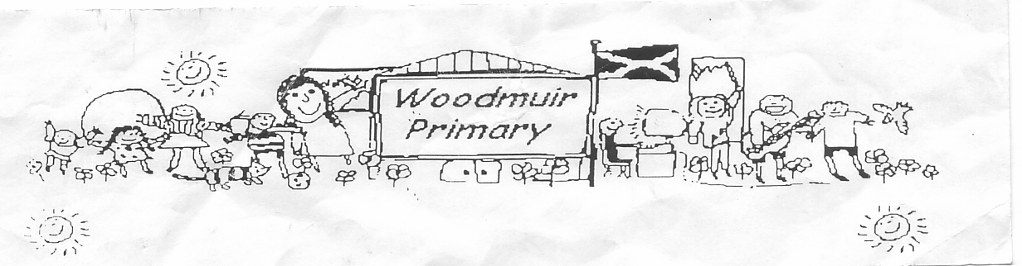
WOODMUIR PRIMARY SCHOOL PARENT COUNCIL MEETING
HELD ON TUESDAY 19th NOVEMBER 2024

Present: - Mrs Henretty, Mrs Rumbles, Mr Johnson, Mrs McLaren, Miss Dunsmore, Mr Cole & Miss Drammeh

Apologies: - See attached sheet

Proposed: Mrs Henretty
Seconded: Mrs Rumbles

Previous Minutes
Mrs Henretty asked if anyone had any questions from the previous minutes. It was agreed to move on as no one had anything.

Head Teacher Update
Communication – Mrs McLaren discussed the issues surrounding communication. Mrs McLaren asked
parents if they were still happy with the one newsletter on the school app. Some parents did not get a
notification. Mrs McLaren explained that the weekly newsletter goes out every week and she got
notifications when they went up. A few parents asked if we were able to check why some parents were not
getting notifications, Mrs Fordyce explained that as this is an external app we have no way of checking but
asked the parents to check their setting within the app. Parents were asked to relay back any findings if
any found so we could advise other parents. Mrs McLaren asked did the parents want us to go back to
Groupcall messages and the parents at the meeting agreed they were happy with the newsletter. It was
advised by Mrs McLaren if for any reason any urgent changes were to be made then this would be relayed
by Groupcall text. It was agreed that if an afterschool club was to be cancelled again then the school
would alert parents through the newsletter and also send an email out to parents on the Monday morning
or as soon as possible.

Family Learning
Mrs McLaren explained that the family learning team were coming in this week to do a workshop with
parents and pupils on Numeracy.

Christmas Fayre
Mrs McLaren explained that we are looking for parent helpers for the Christmas Fayre. Mrs McLaren
discussed in more detail how the morning would run.
Mrs McLaren expressed that this was our main annual fundraiser and she explained how the funds are
Used to help subside outings etc.
Mrs Henretty & Miss Dunsmore discussed between them what Regina (art afterschool club) had planned for
the pupils with crafts for the fayre.
Mrs McLaren spoke through the stall we were planning on having:- Tombola, Raffle (both kids & adults)
Wine ‘n’ Water, Bake stall, face painting, crafts, we were still waiting on AB dad confirming if he was able
to do fake tattoos, Guess how many stall x 2 Paddington Bear & sweets.
Parents who agreed to help on the day – SH, KR & AD.
Mrs Fordyce was asked to send out raffle books to parents.
Discussion then went onto what we had last year. Golden carrot, hook a duck, Reindeer food, hot choc &
sweet cones, Baker Ross games & pet treats.
Mrs Henretty asked if they could have a meeting with Mrs Haston & Mrs Gillies to discuss what was needed
from the Parent Council in help with the organisation for the event.

Parents asked if we were planning on singing around the Christmas tree this year. Miss Dunsmore did not
think there was a time available in the last week as it was so busy. Mrs McLaren suggested Friday 20th
December in the morning. There was a discussion around whether there would be a charity bucket at
either the fayre or the Christmas carol session.
It was agreed that any outside stall holders would pay £5 & a donation towards our raffle.
Mrs McLaren explained that at Longridge they have a clothing bin in the community and we could maybe
enquire about one for Woodmuir as this also helps towards fundraising.

Date for next meeting: Tuesday 28th January 2025 at 3.05pm in school

