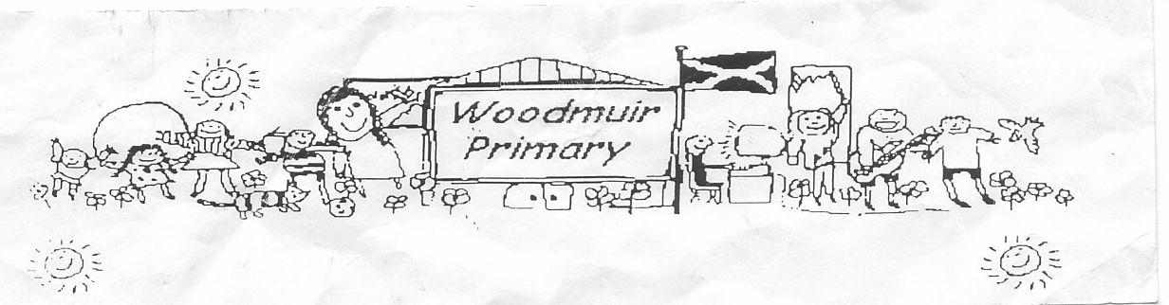
WOODMUIR PRIMARY SCHOOL PARENT COUNCIL MEETING
HELD ON THURSDAY 13th NOVEMBER 2025

Previous Minutes
Previous minutes were shared.
Proposed: Mrs Henretty
Seconded: Mrs Rumbles

Head Teacher Update
Mr McNaughton welcomed everyone to the meeting. Mr McNaughton explained that in Term 1 he wanted
to meet the parents and get to know them, Term 2 How we move forward. Mr McNaughton explained that
we are looking at changing the vision for the school and discussed in more detail what has already been
shared to the pupils.
Mr McNaughton showed the parents the floor books that the children have and went onto more detail what
the pupils are doing.
Mr McNaughton gave all parents our School Improvement priorities and explained what had been started
and what we have still to work on. Mrs Rumbles agreed that some points ned to be removed as too small a
school for them.

Relationship Policy
Mr McNaughton shared where we are with creating a revised Relationship Policy.

Constitution
Mr McNaughton discussed in more detail the school constitution.

Finances
Mr McNaughton shared the budget funds & school funds and what they are used for. He explained that all
fund raising that we do will be spent on the pupils. Aberdour beach, Panto all free.

Chair AOCB
Mrs Henretty shared that there was good feedback from the parents regarding the recent Curriculum Café.
Parents were saying it was a better set up than before with no segregation from pupils & parents. Parents
would prefer the same at further Curricular Café’s and not as before. Mr McNaughton explained that future
curricular café’s would be linked to a priority. Mrs Rumbles shared that getting the dates early helped
prepare for time off work to attend.

Mrs Henretty had mentioned that any Christmas clothing (jumpers etc) that are too small could be put on
the rack to recycle. It was mentioned that bringing the Rag Bag collections into the school at the moment
as it was being raided.
Mrs Henretty also shared that there was a vast improvement since using the Safe Routes to School path,
Mrs Fordyce reminded parents that in poor weather to use the flat path via the car park as the Council
don’t always have the path gritted prior to pupils attending school.

Sustainability Group
Mr McNaughton shared with parents that we had a visit from the Sustainability Group and they met with
some pupils to ask what would be good in the area. Mr McNaughton had suggested a Maintenance station
we have received £1200 to have this installed, we are in the process of working out where this would be
best situated.
There was also a discussion on getting funds from West Lothian Development Fund to convert the sand pit,
the pupils made ideas as part of the Levenseat project.
Mrs McNeil had shared that she was trying to get funding to have a Defibrillator installed somewhere in the
village. She had enquired with British Heart Foundation but was declined. She has since been on to the
Councillor which she is awaiting a form to be sent to complete and possibly get some funds from the
Disbursement Fund. Mrs Fordyce shared that at the sustainability meeting a pupil did suggest this. Mrs
McNeil shared that our Community Council is shared with Addiewell & Loganlea. No funding is given to
Breich.

Christmas Winter Festival
A discussion was had regarding what we had in place for the Winter Festival.
8/9 adult tables
Lots of children’s stalls
Some stall holders were bringing their own tables
Sweet jar – Mrs Henretty was collecting tomorrow
P6/7 pupils were covering the school crafts
Raffle – door-2-door sales
Tombola
Face painting
Photos for Doodles/Santa – Mrs Henretty was making up treat bags for Doodles and would sell for 50p
Santa & Mrs Claus – Mr & Mrs Kerr agreed to dress up
£1 entry fee – Tea/Coffee included
Games that the pupils had made
Deal or No Deal

A further date of Tuesday 25th November at 1.30pm for Parent Council & PSW to meet to go over what else was needed or needing done before fayre.

