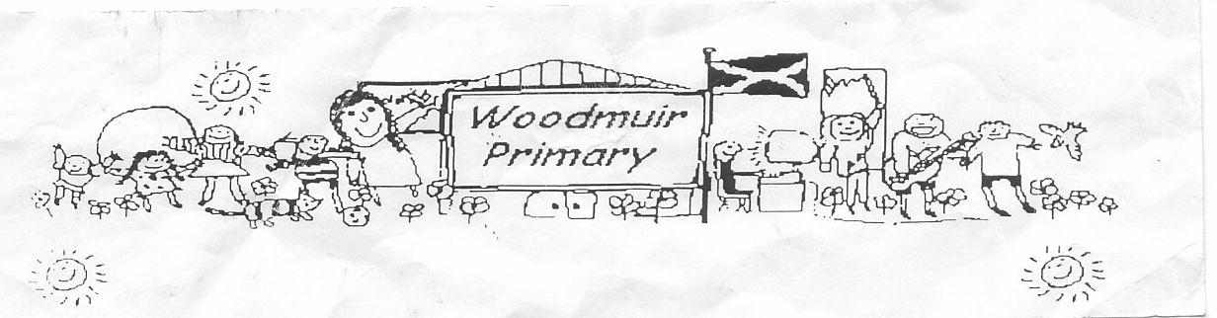
WOODMUIR PRIMARY SCHOOL PARENT COUNCIL AGM MEETING
HELD ON THURSDAY 3RD SEPTEMBER 2026

Present: - Mrs Henretty, Ms Meilke, Mrs Thorburn, Mr McNaughton, Mr Cole

Apologies: - See attached sheet

Mr McNaughton welcomed everyone to the meeting. Mr McNaughton shared that he has enjoyed his time at Woodmuir and explained why he is moving to a new post. Ms Meilke asked who will communicate to parents in Mr McNaughton’s absence. Mr McNaughton explained Mr Neil will be in school a few days per week, Mr McNaughton will still be doing some work for Woodmuir & extra staff will be at Woodmuir to help out.
Mrs Thorburn asked is there a handover process with the new staff member? Mr McNaughton explained what has been done to help with a handover so far and confirmed there will be a handover with the next Head Teacher.
Mr Cole asked is the weekly newsletter continuing? Mr McNaughton replied “yes we will look to have this continue with Mrs Ingram”.

Previous Minutes
Minutes from the previous meeting were read by all present.

Proposed: Mrs Henretty
Seconded: Mr Cole

A.G.M
Mr McNaughton shared that if anyone wished to take over the Chair position or if they were happy with Mrs Henretty continuing as chair. Mr McNaughton asked if anyone would like to become vice-chair which Mr Cole agreed to do and Mrs Fordyce is happy to continue as clerk.

Head Teacher Update
PVG – Mr McNaughton explained that Parent Council members should have a PVG now. Mrs Fordyce was
asked to send the email link to all present members.

Finance – Mr McNaughton went over the expenditure and bank balances. Mr McNaughton went into how
we should spend the school fund money on the pupils. Mr McNaughton went into detail about the cost for
Afterschool clubs, Ms Meilke expressed that she would be happy to pay a little more towards the cost to
allow her children to attend afterschool clubs. There was a discussion regarding costs and it was agreed
that we would keep as is until October and maybe look at charging for both afterschool clubs.
Mr McNaughton mentioned that he would check with staff would be happy to run an afterschool club for a
few weeks.

Office phone PM – Mr McNaughton shared that we had contacted IT regarding transferring the office
phone in the afternoon’s, they replied to advise the phone can be transferred to a staff mobile, Mr
McNaughton explained we have contacted IT and are awaiting their advice around how we can come up
with a solution.

Defibrillator – Mr McNaughton explained that we had a Defibrillator installed in the school during the
summer holidays. Mr McNaughton said that we are so happy to have this but thought we were getting an
outdoor one. This has been installed in the front foyer.

Dates for Diary – Panto – 9th December (Free this will be paid from school funds)
May Day Fun Day – 14th May 2027
Curricular Café – October 2026 – Mrs Blair will be showcasing the work done for the Levenseat project, The Junior Duke awards and Shani will be showcasing the work she is currently doing with the pupils.
Mrs Henretty asked if the Curricular Café can continue to be run like the last few as the parents found
them very useful.

Mr McNaughton also explained that the school improvement plan was already completed.

A.O.C.B. – Mr Cole asked if we could source better paints as both his children’s brand new sweatshirts
were ruined at the start of term as they were unable to get the green paint off them. Ms Meilke also
agreed that one of her boys sweatshirt was the same.

Mrs Henretty asked if there would be an opportunity to bring parents into school to discuss their job roles
with the pupils, Mr McNaughton explained that this can be done when the pupils are doing DYW work.
(Developing Young Workforce)

Date for next meetings: Tuesday 3rd November, Tuesday 12th January 2027, Tuesday 13th April 2027

